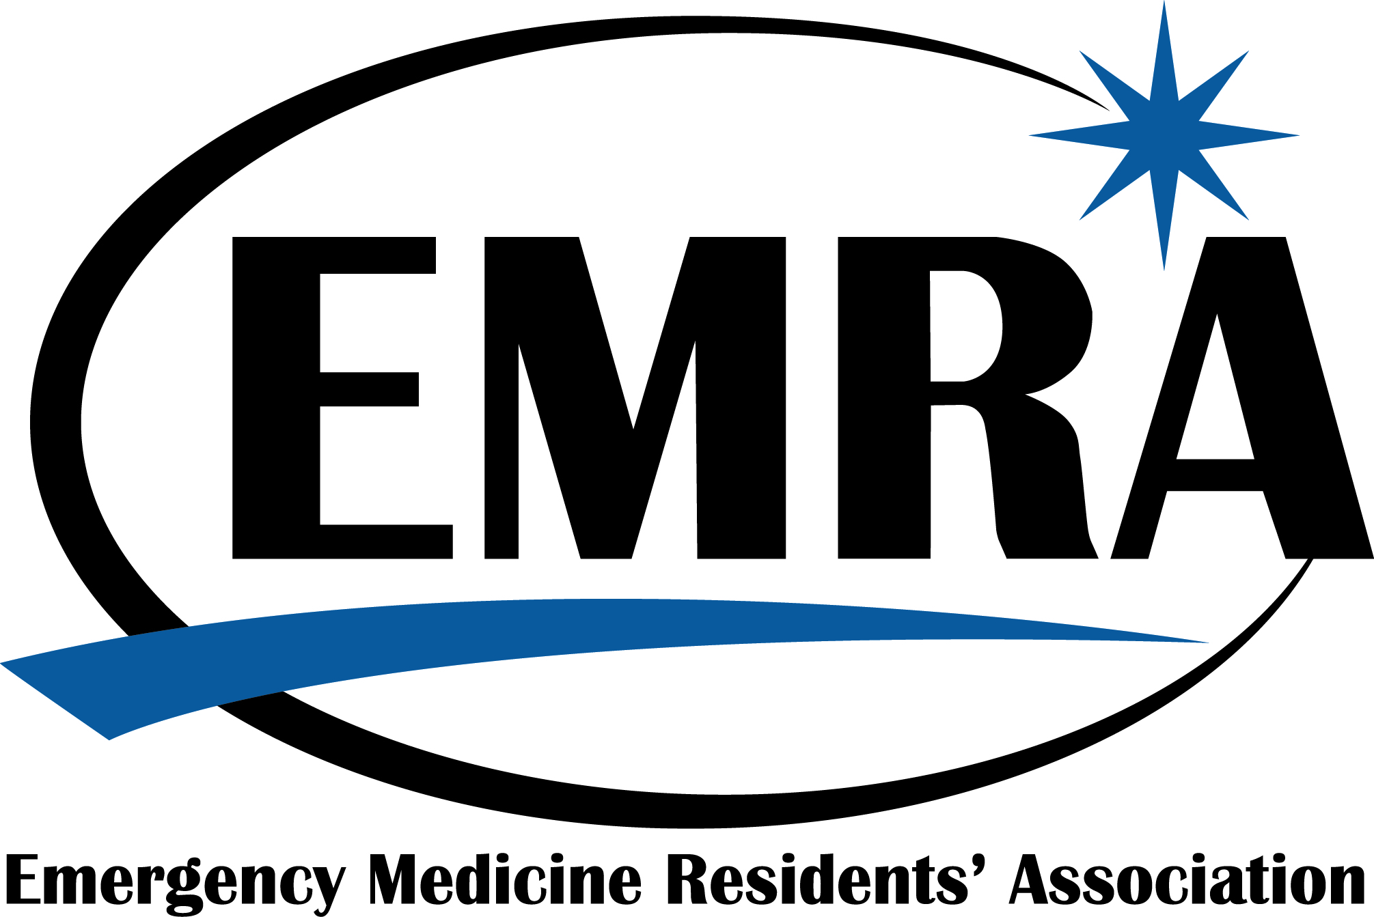

EMRA Simulation Research Grant Proposal Template
Please submit along with your application, letter of support, and CVs of the primary author(s) to the EMRA Awards Coordinator
Email: awards@emra.org
Fax: 972.692.5995

Applicant Name:

Applicant Institution:

Address:
Phone Number:
E-mail:

Purpose of Award: To provide research funding to Emergency Medicine (EM) physician-in-training interested in completing simulation-based projects during residency/medical school. This Grant promotes the involvement of emergency medicine trainees in research which supports the specialty of emergency medicine and its training.
Simulation Research Topics: Simulation Research is broadly defined as scientific investigation designed to furnish new knowledge relating to emergency medical care and medical simulation. Such investigations may focus on basic science research, clinical research, preventive medicine, epidemiology, health care policy, or emergency medicine teaching and education.

Concise description of research project, budget, and schedule for completion (attach additional pages as needed):

How is this project consistent with EMRA's Mission:
EMRA is the voice of emergency medicine physicians-in-training and the future of our specialty.

Who will be involved in carrying out the research and completing the project?

How will EMRA's support be acknowledged? (EMRA must receive appropriate acknowledgement of its support of the project)

What tax exempt entity will serve as administrator for the grant?
Please provide EMRA with the name of the tax-exempt entity (ACEP Chapter, Residency Program, Medical School, e.g.) who has indicated their willingness to serve as administrator for these grant funds should the grant be awarded. This will ensure that income taxes will not apply to your grant funding. Attach a letter from the organization or complete the information below:

Tax-Exempt Organization (this name will appear in the Payable to: line of your grant check):

Contact:

Address (where the grant check will be mailed):

EMRA Simulation Research Grant recipients are required to:
  - Submit a semi-annual progress report to awards@emra.org and simulation@emra.org (6 months into award period)
  - Submit a summary article of their results for EM Resident and
  - Present a report at the membership meeting following the receipt of their grant.

